PHILIP WILSON

GEOTECHNICAL DISPUTES

Consultant Geotechnical and Geo-Environmental Specialist

Philipwilson99@hotmail.co.uk 07985298874

www.wilgeo.co.uk



Education History & Professional Background

2009 Fellow of the Institution of Civil Engineers, FICE

1982 Chartered Civil & Geotechnical Engineer, CEng

1975 Kings College, University of London, BSc (Hons), Civil Engineering

1969 Wade Deacon Grammar School for Boys, Widnes,

1985 Federal Aviation Authority (FAA) Private Pilots Licence
PPL single engine land fixed wing airplanes up to 2500kg

1976 Full UK driving licence

Key Skills

- UK and International Geotechnical Expert for Dispute Resolution with Client, Consultant and Contractor Organisations.

- Bond Solon Expert Witness CUB

- Cross examined by National Audit Office/Public Accounts Committee for highway construction and contractual disputes on behalf of Dft as expert witness.

- Onshore and Offshore Geotechnical Engineering

- Contributor to National & International Geotechnical Standards

- Client Skills and Client Liaison

- Supervising Civil Engineer (SCE) on behalf of Institution of Civil Engineers

- PTS Safety Card

Selected Geotechnical Disputes

National Audit Office (NAO)/Public Accounts Committee (PAC)

Provided briefing and expert witness reports for cross examination by NAO/PAC into Geotechnical cost increases on Highway construction costs, which comprised the biggest contribution to cost overrun.

Thaumasite

Expert witness report and Ministerial briefing for Parliamentary Questions (PQ) into concrete attack on concrete bridge foundations by Thaumasite, a rare phenomena, which required revision to BRE National Guidance on sulphates

ICE Managing Geotechnical Risk

Invited by ICE to join expert committee to reduce disputes due to unforeseen ground conditions.

CIRIA Transport Earthworks

Invited by CIRIA to advise on R&D program to produce guidance to reduce geotechnical disputes on Transport construction projects (Road & Rail)

Highways England

Head of Geotechnics, responsible for resolving all geotechnical disputes on Highway construction contracts as nominated expert advising Ministers and Chief Highway Engineer

MCHW/DMRB

Responsible for revising 500 (Drainage) and 600 (Earthwork) series to reduce geotechnical disputes in response to resolution of disputes based on feedback from contracts.

Property Services Agency

Resolution of disputes on behalf of HM Govt on Public Sector contracts for piling, foundations and earthworks

ADNOC Weak Carbonate Rocks

Retained to produce Expert Report on behaviour of piles in weak carbonate rocks that had previously caused disputes over relative merits of bored versus driven piles in these unusual rock types.

Landfill EA Guide

Invited to join expert committee by Environment Agency to provide expert guidance on landfill liner materials to avoid further disputes on specification of liner materials.

Employment History

2019 – Present Dispute Resolution and Independent Geotechnical Consultant
WILGEO Ltd

2018 –2019 Lead Geotechnical
HS2 Phase2b

2017 –2018 Head of Geotechnics
EMS Geo-Environmental

2017 Final Reviewer and Approver
Chelmer Global Ltd

2017 Employers Representative
Crest Developments / Campbell Reith

2016 –2017 Director & Owner
WILGEO Ltd

2015 –2016 Associate Director (Geotechnical Engineering)
CAPITA SPECIAL PROJECTS

2014 –2015 Head of Structures & Geotechnical Engineering
BALFOUR BEATTY Ltd

2013 –2014 Head of Geotechnical Engineering
DEEPOCEAN UK Ltd

2012 –2013 Director & Owner
WILGEO Ltd

2009 –2012 Associate Director/Director of Geotechnics
Egniol Environmental Ltd

2008 –2009 Assistant Chief Engineer
Metronet

2005 – 2008 Independent Geotechnical Consultant
Wilgo Geo

2003 – 2005 Business Manager (Principal)
Office of the Deputy Prime Minister (ODPM)

2002 – 2003 Team Leader (Policy)
Department for Transport (DfT)

1992 – 2002 Group Manager & Head of Geotechnics
Highways Agency, Directorate of Quality Services Civil Engineering.

1985 – 1992 Team Leader (Principal Grade)
Dept of Environment / Property Services Agency

1977 – 1985 Project Engineer
Dames & Moore International

1975 – 1977 Graduate Engineer
Rofe Kennard & Lapworth Consulting Engineers

1974 Graduate Engineer
North West Road Construction Unit

Major Committees served and represented UK Plc

World Road Association (PIARC) Technical Committee TC12

CEN/BSI European Product Standard for Geotextiles

CEN/BSI Eurocode EC7 Geotechnics

BSI B526 Code of Practice for Site Investigation BS5930

BSI B526 Code of Practice for Laboratory Testing BS 2001

Chairman Technical Project Board (TPB) Manual of Contract Documents for Highway Works MCHW1 500Series Drainage & 600 Series Earthworks

Chairman Technical Project Board (TPB) Design Manual for Roads and Bridges DMRB Vol4 (HD22/92 Geotechnical Certification, HA44/91 Earthworks, Advice Note for Maintenance of Highway Earthworks, Geotechnical Data Management System GDMS pilot etc. )

CIRIA Steering Group for evaluating Geotechnical R&D Proposals from Industry and Government. Invited member of CIRIA workshops to brainstorm future strategic direction eg sustainability, Eurocodes etc

Transport Research Laboratory (TRL) Key customer for TRL as Highways Agency commission £1M pa Geotechnical spend under customer held budgets (CHB). Customer policy approval of TRL R&D reports prior to placement in public domain

Chairman Highways Agency Geotechnics & Ground Engineering (GAGE) Group Manager reviewing monthly spend and business plan targets, £250k pa geotechnical call off contract for Geotechnical Certification HD22/92. Final approval and point of responsibility within HA for all geotechnical proposals and departures from standard on D&B, DBFO, PFI contracts

Selby Rail/Road Crash team member of working group to prepare proposals and costs to re-open line and highway in the immediate aftermath of the incident.

National Audit Office (NAO) Study into sources of cost increases on highway construction contracts. Preparation of briefing material for Permanent Secretary appearance before Public Accounts Committee (PAC) hearing.

Institution of Civil Engineers Steering Group Volumes 1 to 4 Without Site Investigation Ground is a hazard

Institution of Civil Engineers Steering Group on Risk Management within Geotechnics

Institution of Civil Engineers Working Group Specification for Site Investigation, subsequently adopted in Highways Agency documentation in MCHW1

Institution of Chartered Surveyors Specification for Geodetic (Topographic) surveys, subsequently adopted in Highways Agency documentation.

International Conferences And Trade Fairs Principal speaker for Highways Agency on Geotechnical matters including media appearances and public relations liaison, briefing for ministers and senior HA officials.

Interests and Leisure Pursuits

Public Speaking, Keep Fit, Swimming & Scuba, Walking/Hiking, Skiing, Cycling, Motoring &Historic Cars, Private Flying &Gliding, Popular & Classical Music, Art and Sketching

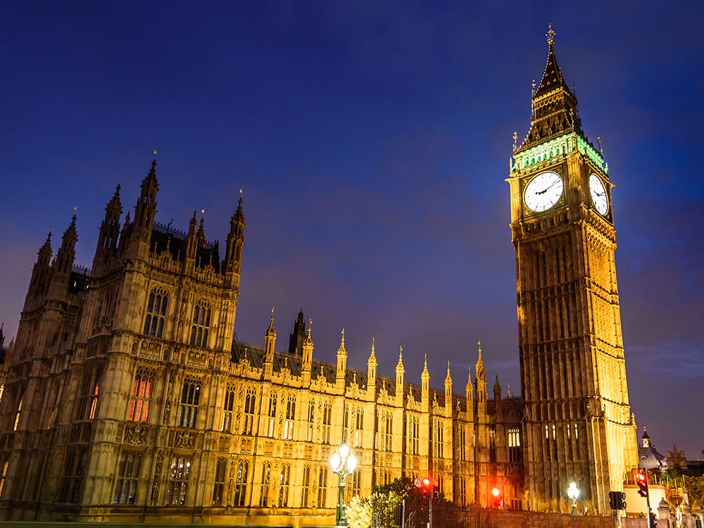

National Audit Office (NAO)/Public Accounts Committee (PAC)
Provided briefing and expert witness reports for cross examination by NAO/PAC into Geotechnical cost increases on Highway construction costs, which comprised the biggest contribution to cost overrun.

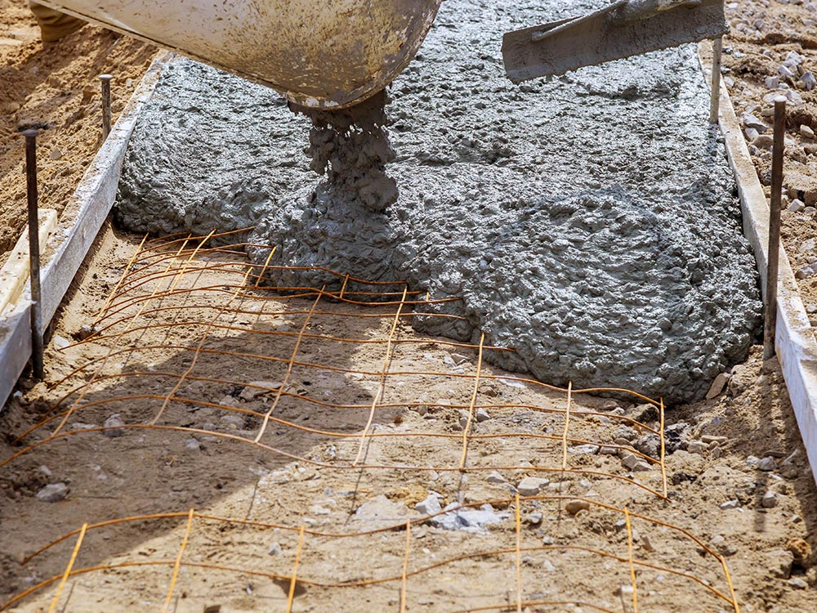

Thaumasite
Expert witness report and Ministerial briefing for Parliamentary Questions (PQ) into concrete attack on concrete bridge foundations by Thaumasite, a rare phenomena, which required revision to BRE National Guidance on sulphates.

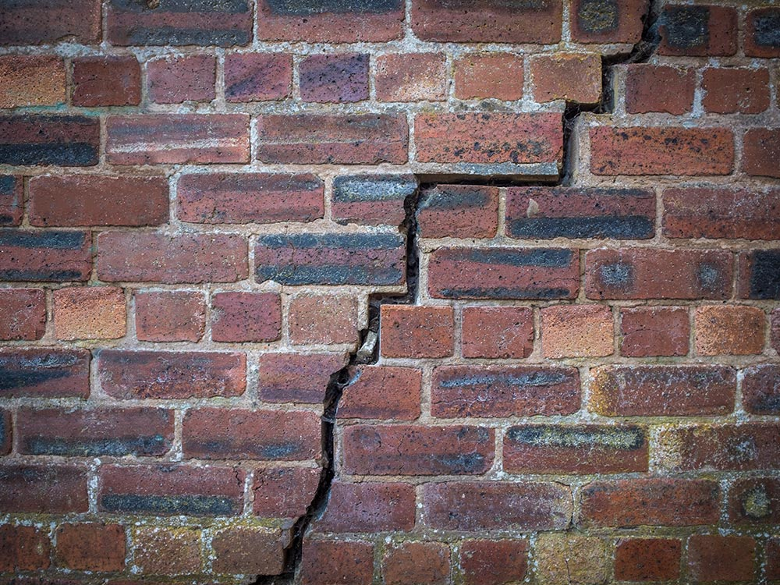

ICE Managing Geotechnical Risk
Invited by ICE to join expert committee to reduce disputes due to unforeseen ground conditions.

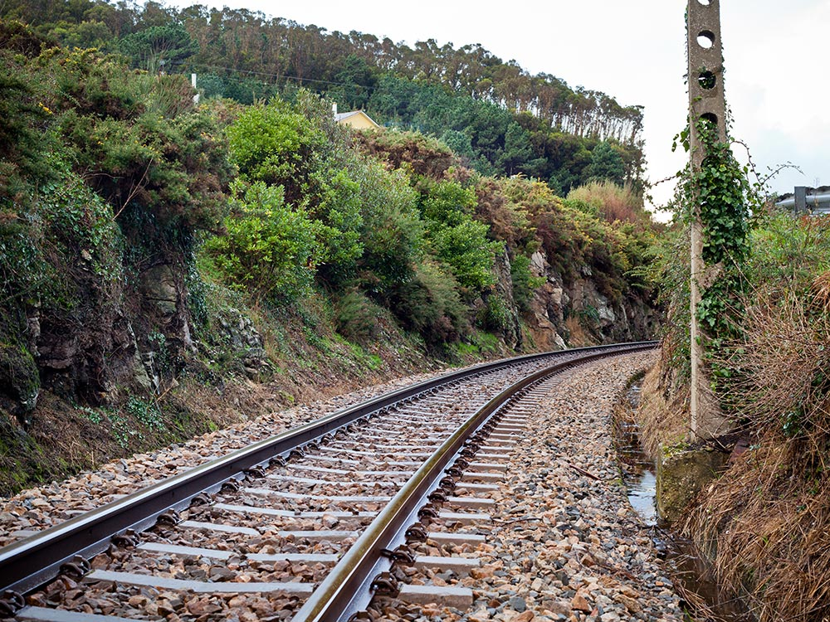

CIRIA Transport Earthworks
Invited by CIRIA to advise on R&D program to produce guidance to reduce geotechnical disputes on Transport construction projects (Road & Rail).

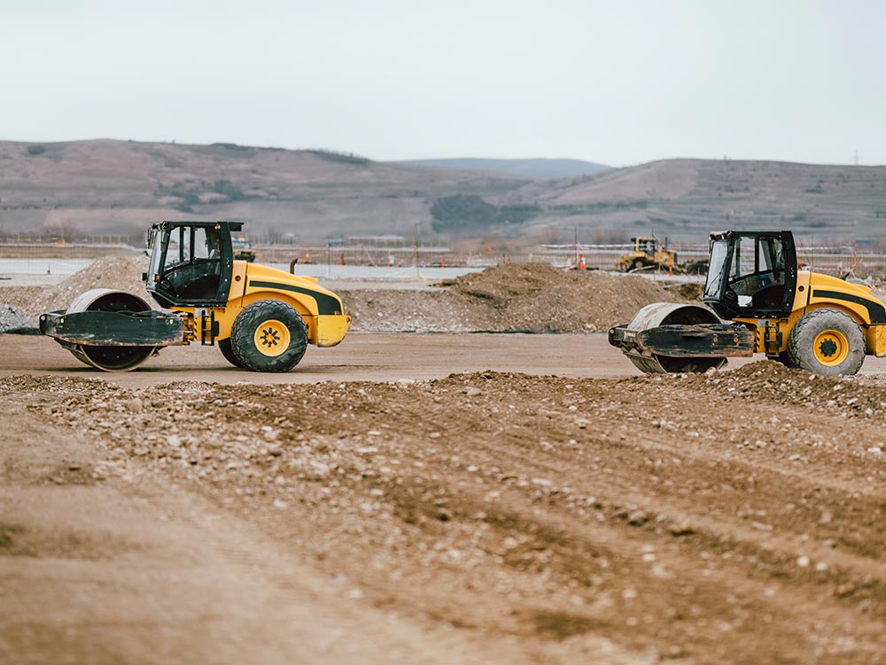

Highways England
Head of Geotechnics, responsible for resolving all geotechnical disputes on Highway construction contracts as nominated expert advising Ministers and Chief Highway Engineer.
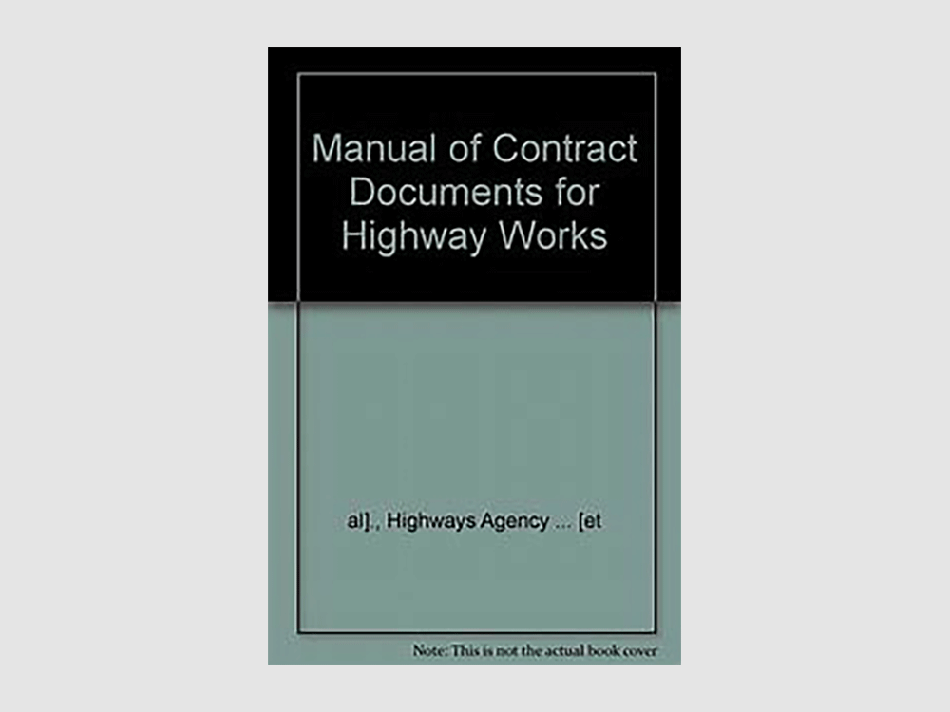

MCHW/DMRB
Responsible for revising 500 (Drainage) and 600 (Earthwork) series to reduce geotechnical disputes in response to resolution of disputes based on feedback from contracts.

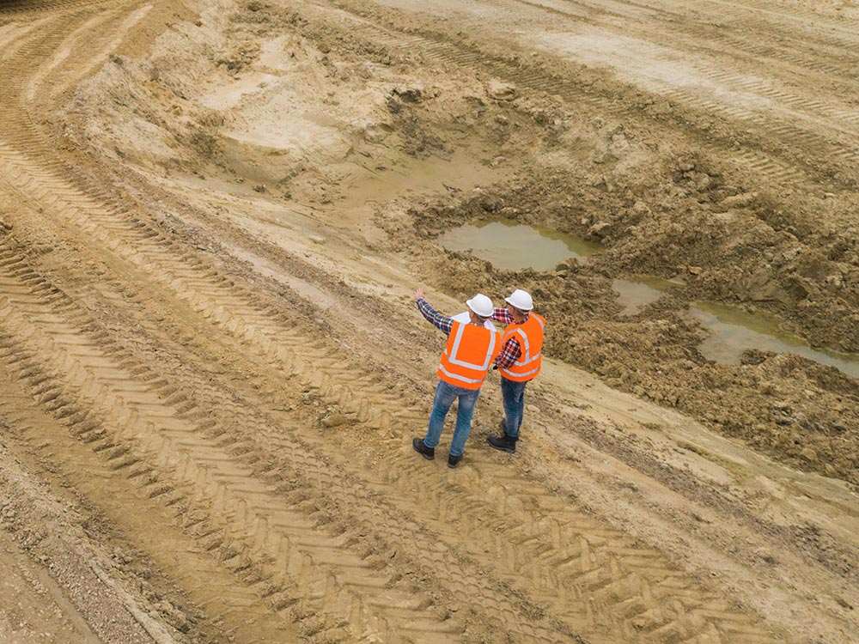

Property Services Agency
Resolution of disputes on behalf of HM Govt on Public Sector contracts for piling, foundations and earthworks.



ADNOC Weak Carbonate Rocks
Retained to produce Expert Report on behaviour of piles in weak carbonate rocks that had previously caused disputes over relative merits of bored versus driven piles in these unusual rock types.
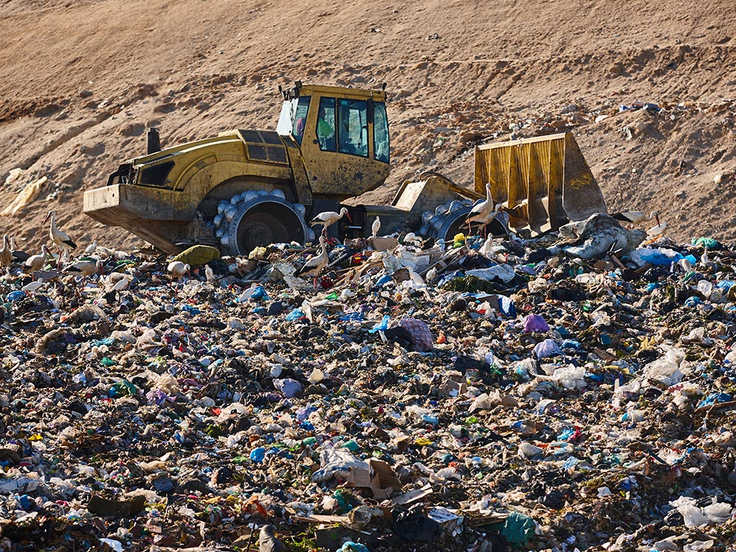

Landfill EA Guide

Please see my disputes website for further information: www.wilgeoexpertwitness.co.uk

